ADT Lab Exercise – 8 ANUGRAHAA V - 2648506
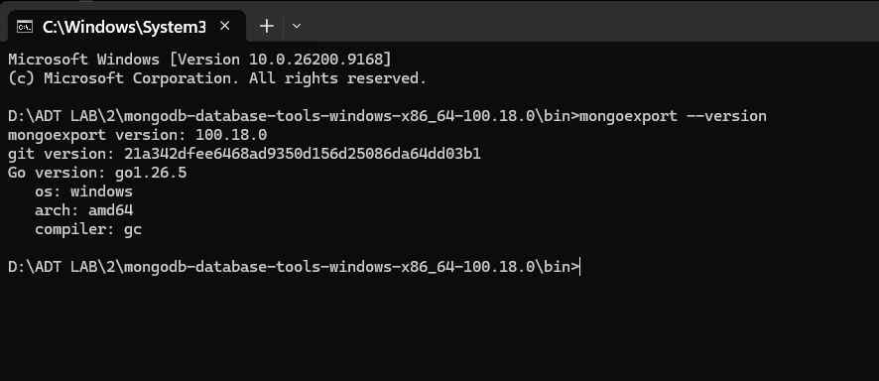
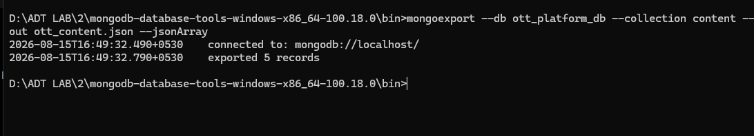
The mongoexport utility was used to export the existing OTT content records from the content collection of the ott_platform_db database into a JSON file named ott_content.json. The output confirms that 5 records were successfully exported, creating an external copy of the collection data.
Import the Prepared Dataset
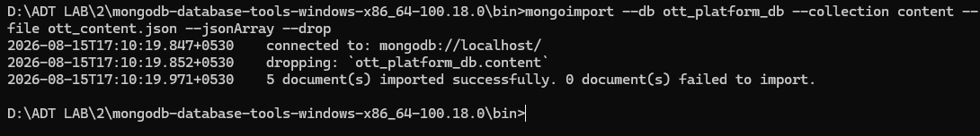
The mongoimport utility was used to import the prepared OTT content dataset from the ott_content.json file into the content collection of the ott_platform_db database. The --drop option was used to remove the existing collection before importing the dataset, thereby preventing duplicate records. The imported dataset contains the existing 5 OTT content records.
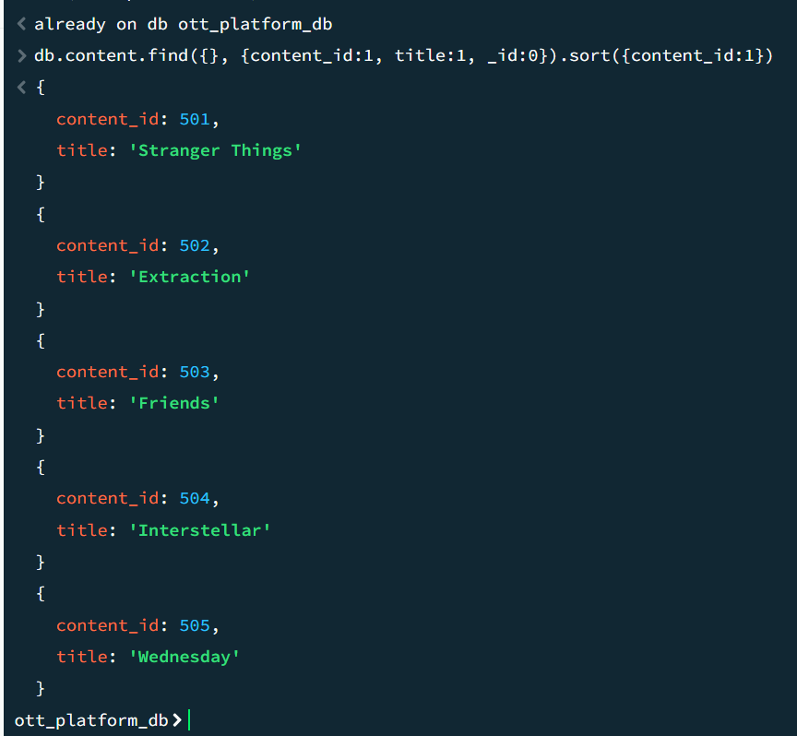
The existing documents in the content collection were displayed using a projection to show the content_id and title fields. The records were sorted by content_id to identify the existing content IDs before adding new records. This helps avoid duplicate content IDs when appending additional records.
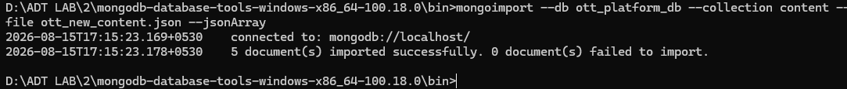
Five additional OTT content records were appended to the existing content collection using the mongoimport utility. The new records were stored in a separate JSON file and imported without using the --drop option. Therefore, the existing records were retained and five new records were successfully added to the collection.
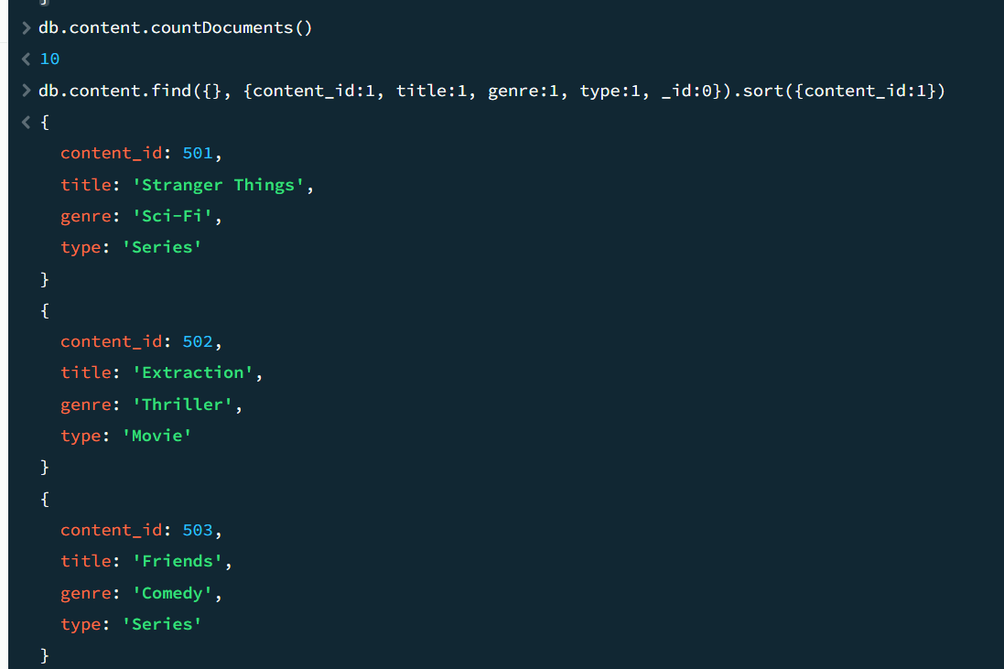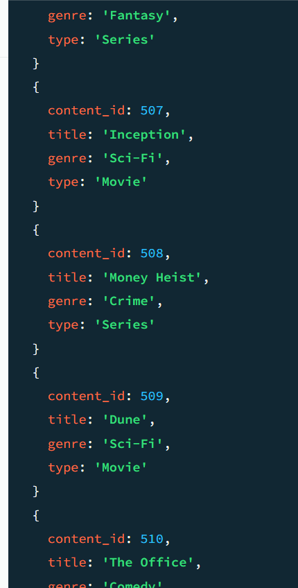
The countDocuments() operation was used to verify the number of documents in the content collection after the append operation. The collection now contains 10 documents, consisting of the original 5 OTT content records and the 5 newly imported records. The find() operation was also used to verify the details of the appended records.
Export the Updated content Collection
The updated content collection was exported using the mongoexport utility into the ott_content_updated.json file. The collection contained the original 5 records and the 5 newly appended records, resulting in a total of 10 records. The export operation created an external JSON copy of the updated OTT content dataset.
Backup the MongoDB Database using mongodump
The mongodump utility was used to create a backup of the ott_platform_db database. The backup was stored in the ott_backup directory. This operation creates a binary backup of the database collections, which can later be used to restore the database using mongorestore.
Delete Selected Documents
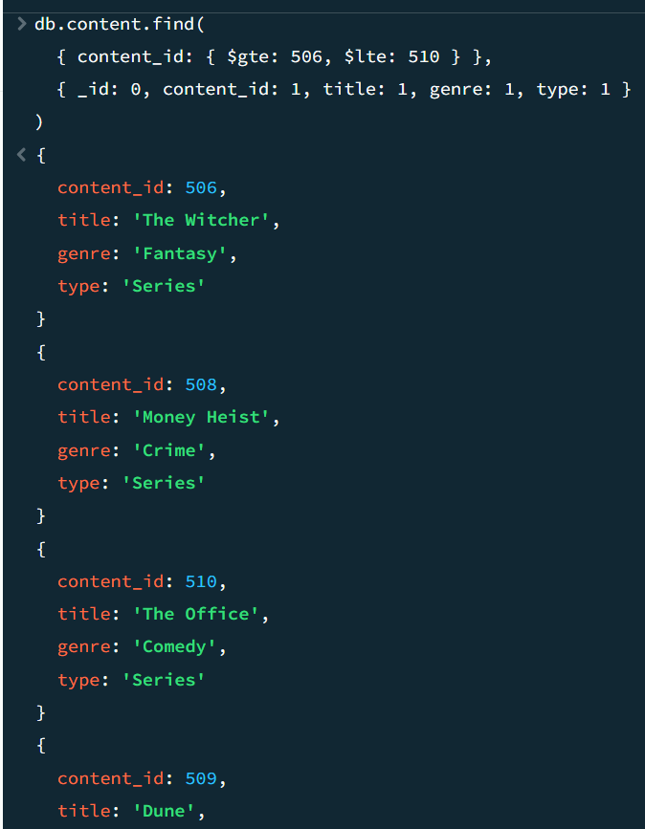
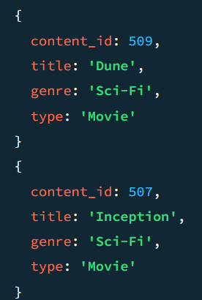
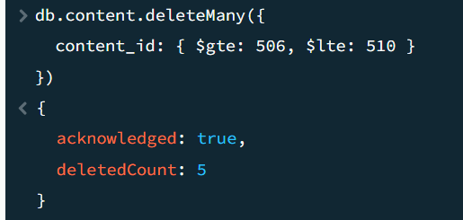
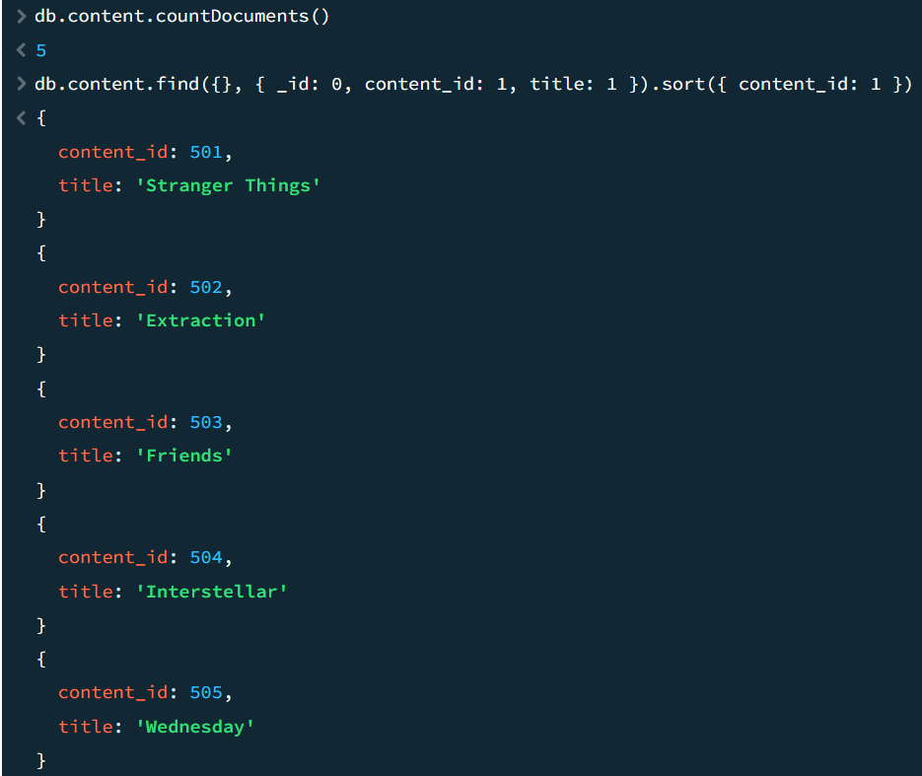
The deleteMany() method was used to remove the five newly appended OTT content records with content_id values from 506 to 510. The output confirmed that five documents were deleted successfully. The document count was then checked and showed five remaining documents, confirming that the selected records had been removed.
Restore the deleted records using mongorestore.
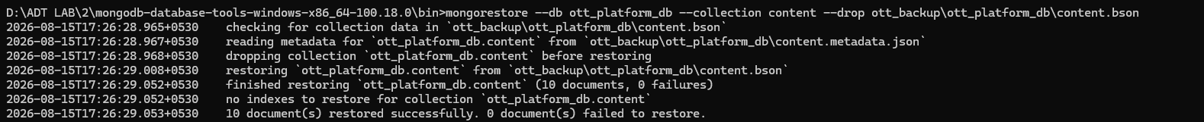
The mongorestore utility was used to restore the content collection from the backup created using mongodump. The --drop option was used to replace the current collection with the backed-up version. This restored the previously deleted OTT content records and demonstrated the recovery of data from a database backup.
Verify that the database and collection were restored successfully.
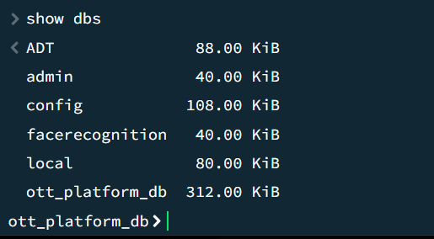
The show dbs command was executed to verify that the ott_platform_db database is available after the restoration operation.
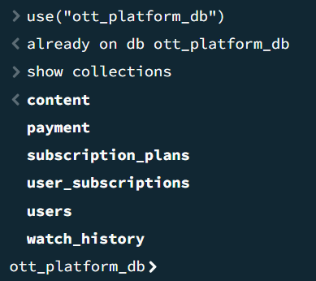
The show collections command was used after selecting the ott_platform_db database to verify that the database collections were restored successfully.
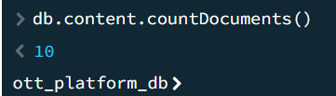
The countDocuments() method was used to verify the number of documents in the restored content collection. The result of 10 confirms that the original five records and the five appended records were successfully restored.
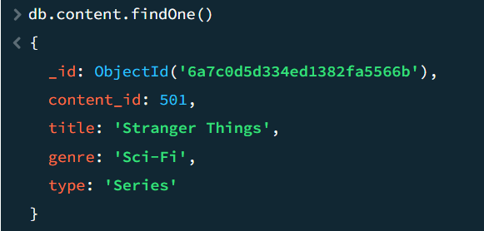
The findOne() method was used to display a sample document from the restored content collection. This confirms that the document data was successfully recovered after the restoration operation.
Create an Index on content_id
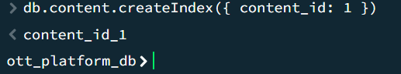
An ascending index was created on the content_id field of the content collection. Since content_id uniquely identifies each OTT content item, indexing this field allows MongoDB to locate content records more efficiently when queries use content_id.
Verify the Index
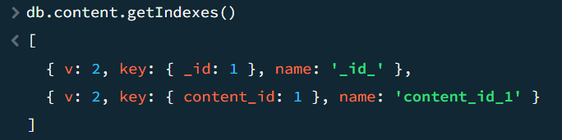
The getIndexes() method was used to verify that the index on content_id was successfully created and is present in the content collection.
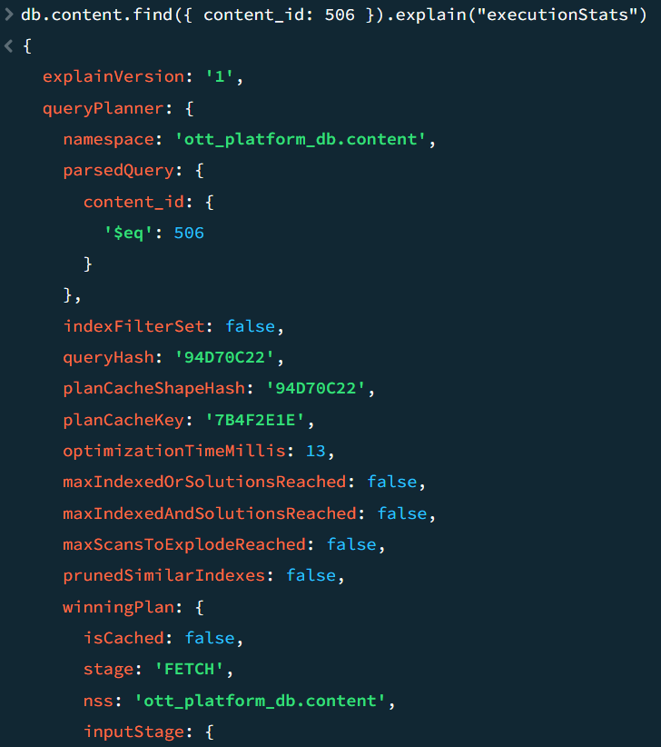
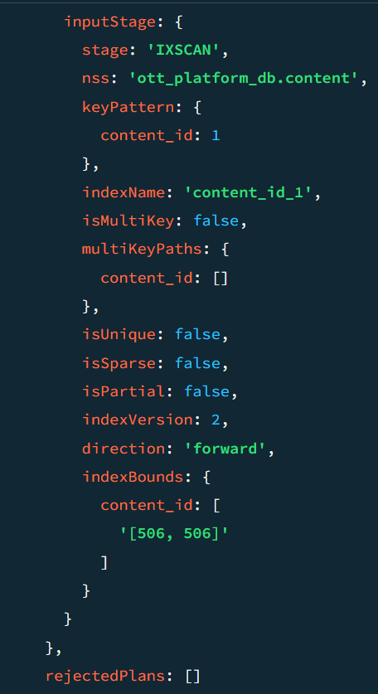
The query was executed on the indexed content_id field using explain("executionStats") to examine the query execution plan. The presence of the IXSCAN stage indicates that MongoDB used the content_id index to locate the required document instead of performing a complete collection scan. Therefore, the index helps improve the efficiency of content retrieval.

